19.12: At constant volume, the work done by the system is zero, so 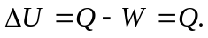Because heat flows into the system, is positive, so the internal energy of the system increases.

